Assignment 1: Installation of Hypervisors and initiation of VMs with image file. Install and configure an open-source hypervisor and create/instantiate a Virtual Machine (VM) using an existing image file. Demonstrate the successful installation and execution of the VM.
Tasks
• Install an open-source hypervisor such as Oracle VirtualBox
• Obtain a suitable VM image/ISO file.
• Create a new VM using the hypervisor.
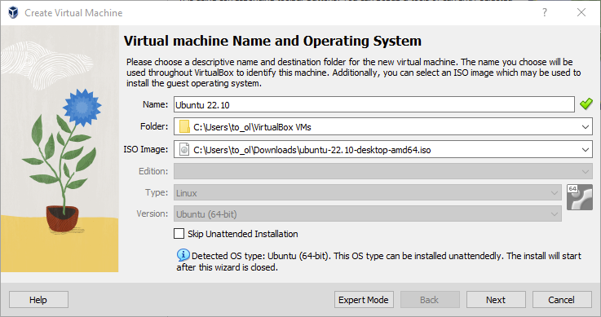
• Configure the VM's CPU, RAM, storage, and network.
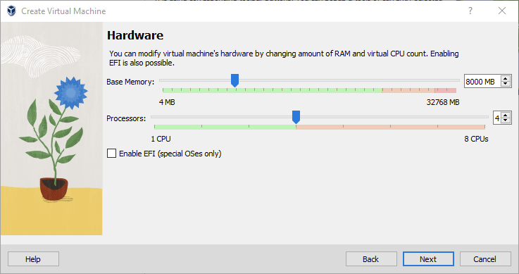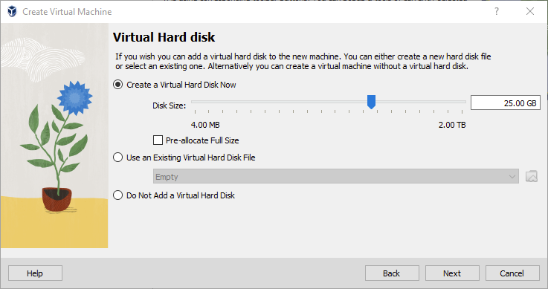
• Attach the image/ISO file to the VM.
• Start and boot the VM.
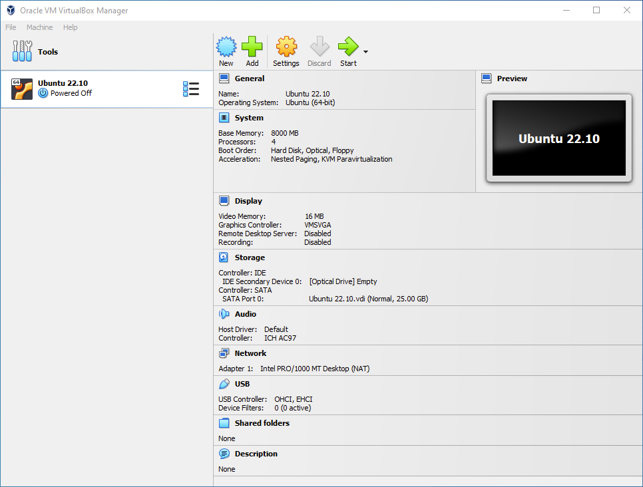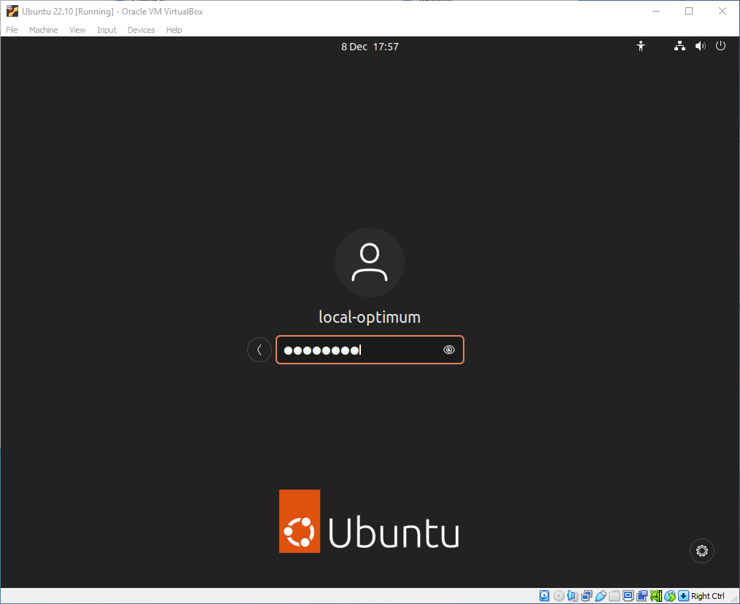
• Complete the guest OS installation, if required.
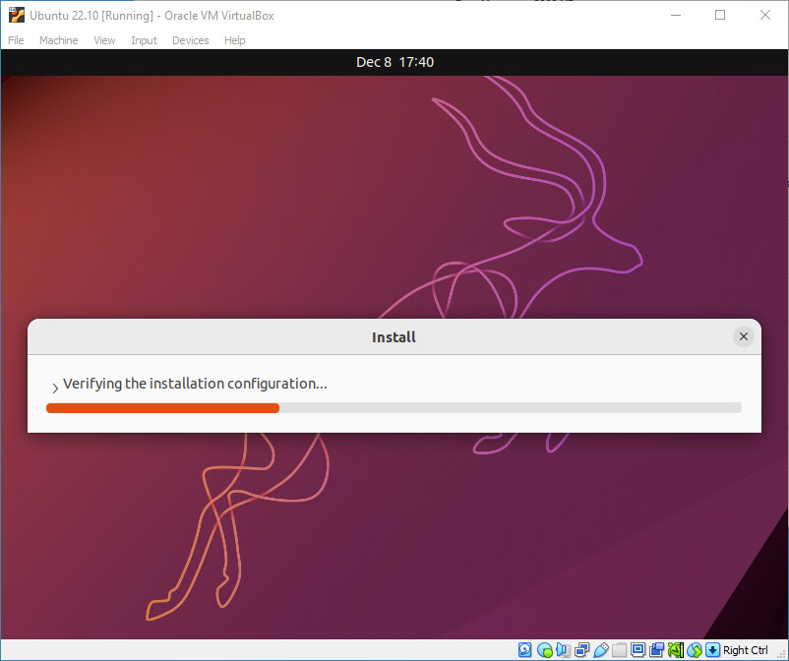
• Verify that the VM is running successfully.
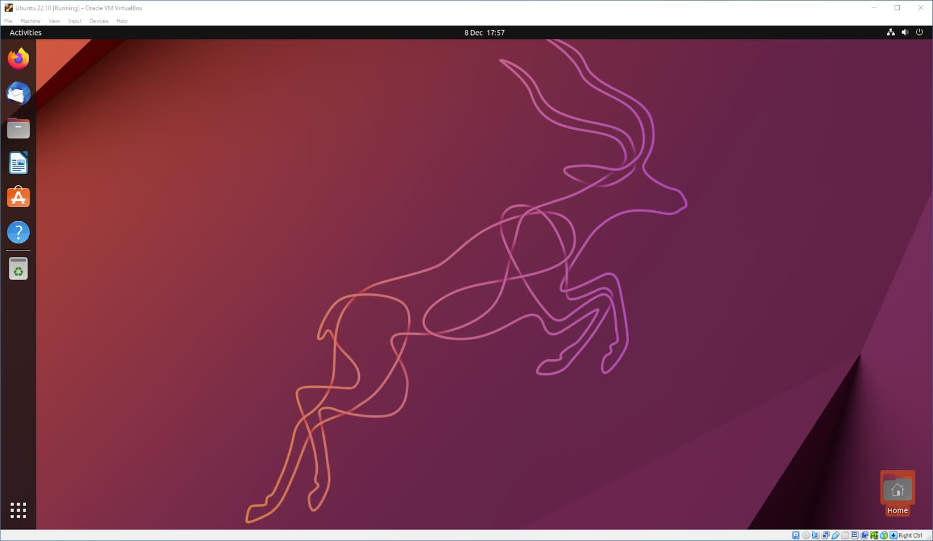
• Installing the required build tools and Linux kernel headers using the below commands: sudo apt update sudo apt install -y build-essential linux-headers-$(uname -r) • Record the configuration and capture relevant screenshots.

